**HADOOP DOCUMENTATION**

1.To list the contents of root folders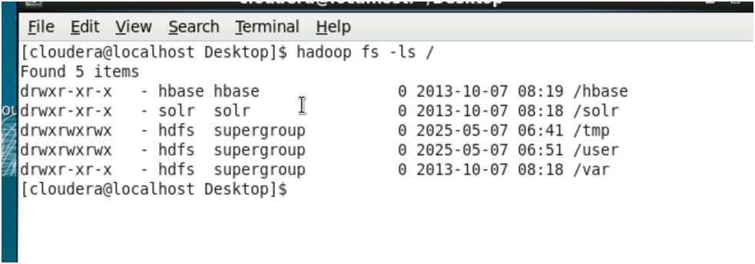

2.To list the contents of the directory user

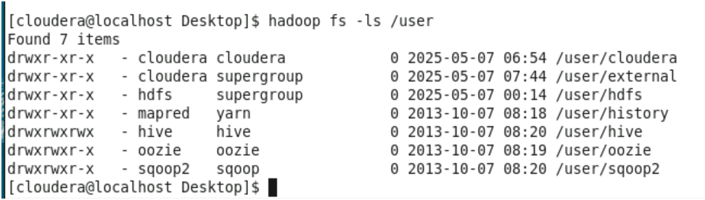

3.To create a folder on another folder and check whether it is created or not

4.To copy and upload a file from its source location to another location and open the file from its new location



5.To check the health details of a file

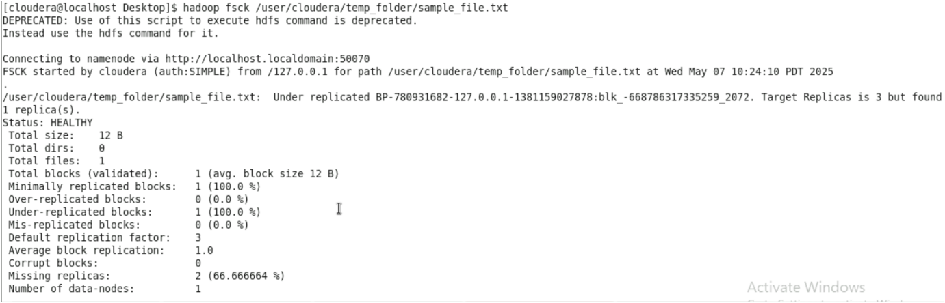

6. To change the replication factor



7. To remove file from a folder